Ethiopia

## Respect for rule of law (ROL) data

The data set shows the data on the respect of the rule of law for the country.

## # A tibble: 19 x 5  
## country iso3c date ruleOfLaw ruleOfLawCategory4   
## <chr> <chr> <dbl> <dbl> <chr>   
## 1 Ethiopia ETH 1996 -0.966 ROL moderately disrespected  
## 2 Ethiopia ETH 1998 -0.798 ROL moderately disrespected  
## 3 Ethiopia ETH 2000 -0.929 ROL moderately disrespected  
## 4 Ethiopia ETH 2002 -0.940 ROL moderately disrespected  
## 5 Ethiopia ETH 2003 -0.828 ROL moderately disrespected  
## 6 Ethiopia ETH 2004 -0.861 ROL moderately disrespected  
## 7 Ethiopia ETH 2005 -0.936 ROL moderately disrespected  
## 8 Ethiopia ETH 2006 -0.660 ROL moderately disrespected  
## 9 Ethiopia ETH 2007 -0.649 ROL moderately disrespected  
## 10 Ethiopia ETH 2008 -0.697 ROL moderately disrespected  
## 11 Ethiopia ETH 2009 -0.827 ROL moderately disrespected  
## 12 Ethiopia ETH 2010 -0.802 ROL moderately disrespected  
## 13 Ethiopia ETH 2011 -0.740 ROL moderately disrespected  
## 14 Ethiopia ETH 2012 -0.677 ROL moderately disrespected  
## 15 Ethiopia ETH 2013 -0.647 ROL moderately disrespected  
## 16 Ethiopia ETH 2014 -0.472 ROL moderately disrespected  
## 17 Ethiopia ETH 2015 -0.509 ROL moderately disrespected  
## 18 Ethiopia ETH 2016 -0.492 ROL moderately disrespected  
## 19 Ethiopia ETH 2017 -0.454 ROL moderately disrespected

## Respect for rule of law (ROL) trend

The plot shows the trend of the respect for the rule of law for the country.

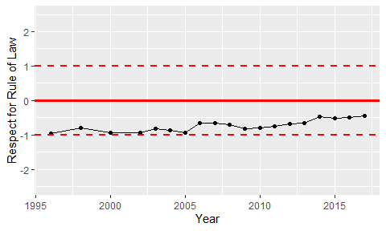

Trend of the Respect for the Rule of Law